Jeremy Rios-Martinez

Comsc 265

Lab 15 -16

**String Library Functions**

In this assignment you will obtain experience with strings and pointers by designing and implementing your version of several string library functions. You are to implement the following functions:

**int Length(char *s);** *This function returns the length of the null-terminted character string s.*

int main()

{

int lengthOfString;

char str[] = {"test string"};

lengthOfString = Length(str);

cout << "The string \"" << str << "\" has " << lengthOfString << " characters." << endl;

system ("pause");

return 0;

}

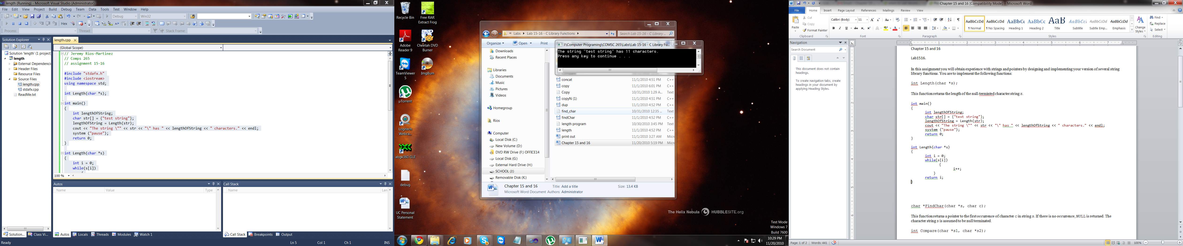

int Length(char *s)

{

int i = 0;

while(s[i])

{

i++;

}

return i;

}

**char *FindChar(char *s, char c);** *This function returns a pointer to the first occurrence of character c in string s. If there is no occurrence, NULL is returned. The character string s is assumed to be null terminated.*

int main()

{

int lengthOfString;

char *pfirst_occur;

char letter = 'r';

char str[] = {"test string"};

pfirst_occur = FindChar(str, 'r');

cout << "In the string \"" << str << "\" the first occurence of \'"

<< *pfirst_occur << "\' is at addres " << &pfirst_occur << endl;

system ("pause");

return 0;

}

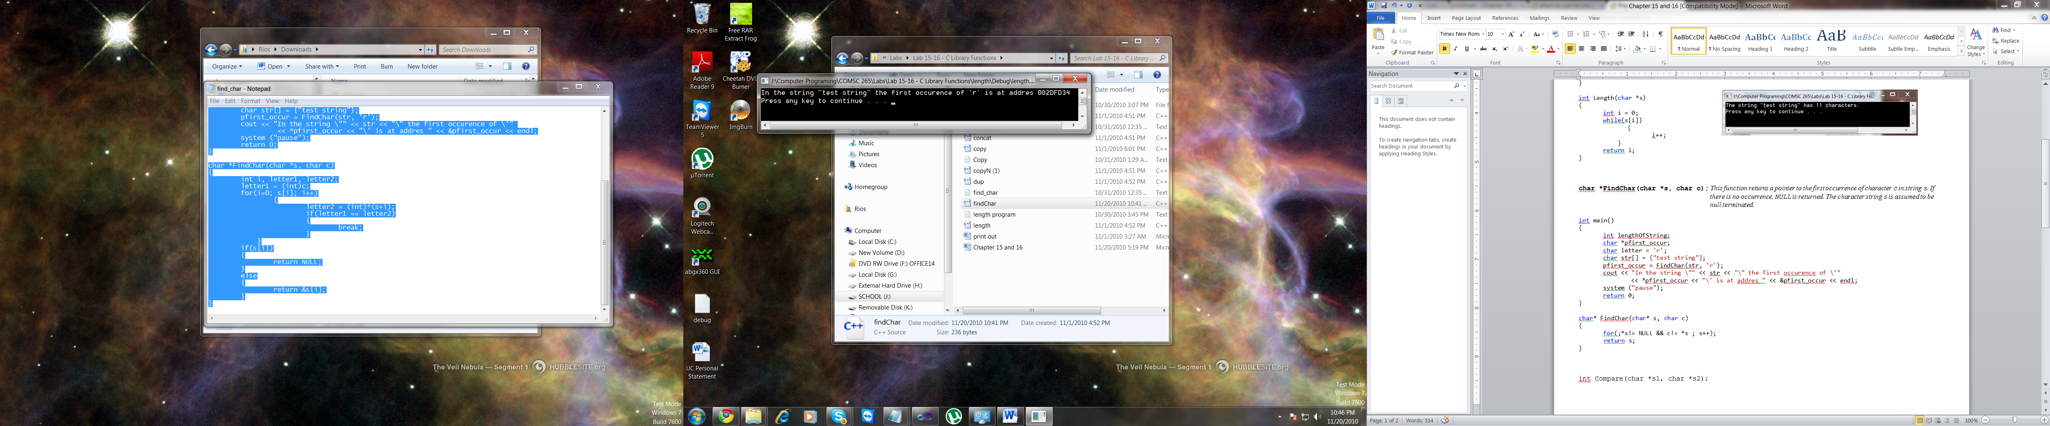

char* FindChar(char* s, char c)

{

for(;*s!= NULL && c!= *s ; s++);

return s;

}

**int Compare(char *s1, char *s2);** *This function returns an integer based on comparing the null-terminated character strings s1 and s2. If the strings are equal, zero is returned. If not, a positive (negative) integer is returned if s1 is lexicographically greater (less) than s2.*

int main()

{

char s1[] = {"apple"};

char s2[] = {"banna"};

cout << "Comparing " << s1 << " to " << s1 << "= " << Compare(s1, s1) << endl;

cout << "Comparing " << s2 << " to " << s1 << "= " << Compare(s2, s1) << endl;

cout << "Comparing " << s1 << " to " << s2 << "= " << Compare(s1, s2) << endl;

system ("pause");

return 0;

}

int Compare(char *s1, char *s2)

{

int i, letter1, letter2;

for(i=0; s1[i]; i++)

{

letter1 = (int)s1[i];

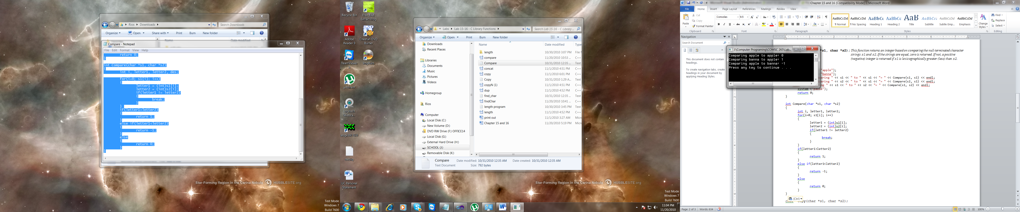 letter2 = (int)s2[i];

if(letter1 != letter2)

{

break;

}

}

if(letter1>letter2)

{

return 1;

}

else if(letter1<letter2)

{

return -1;

}

else

{

return 0;

}

}

**char *Copy(char *s1, char *s2);** *This function copies character string s2 to s1, including the null character. It is assumed that s1 has been allocated enough memory. A pointer to character string s1 is returned.*

int main()

{

char str1[20] = {"apple"};

char str2[20] = {"banana"};

cout << "Before copy str1: " << str1 << " and str2: " << str2 << endl;

Copy(str1, str2);

cout << "After copy str1: " << str1 << " and str2: " << str2 << endl;

system ("pause");

return 0;

}

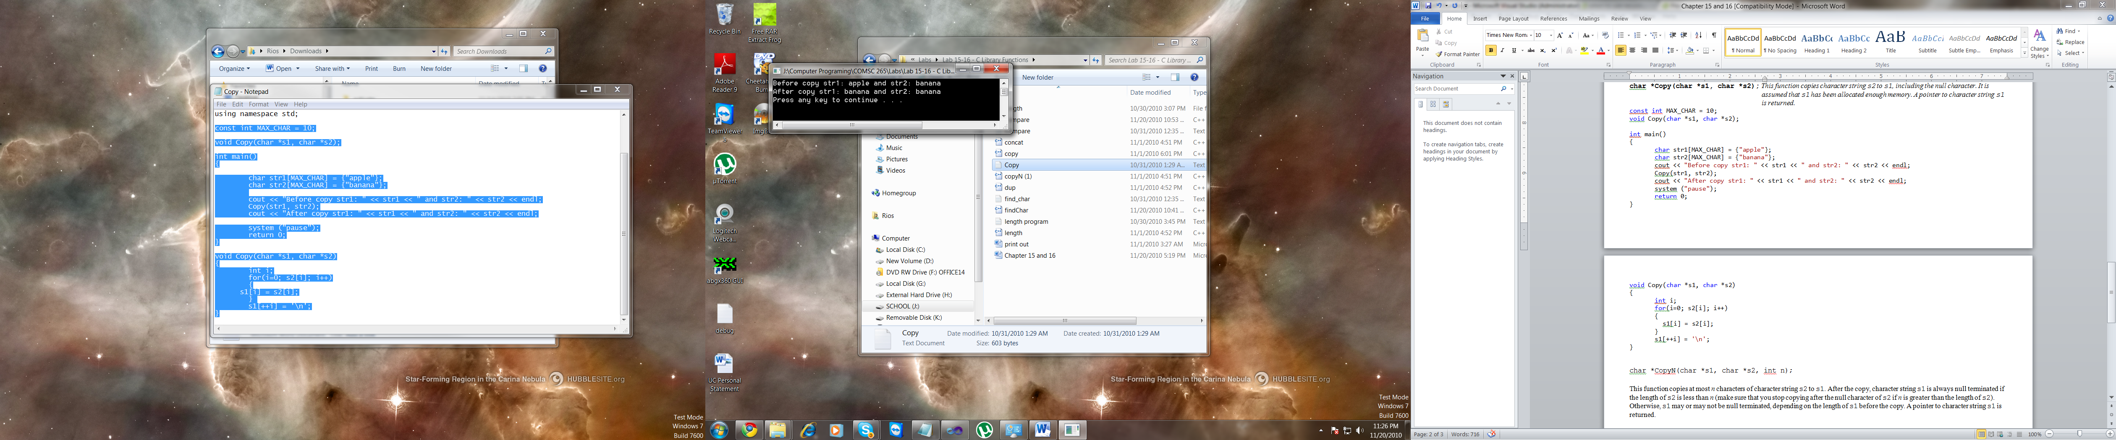void Copy(char *s1, char *s2)

{

int i;

for(i=0; s2[i]; i++)

{

s1[i] = s2[i];

}

s1[++i] = '\n';

}

**char *CopyN(char *s1, char *s2, int n);** *This function copies at most n characters of character string s2 to s1. After the copy, character string s1 is always null terminated if the length of s2 is less than n (make sure that you stop copying after the null character of s2 if n is greater than the length of s2). Otherwise, s1 may or may not be null terminated, depending on the length of s1 before the copy. A pointer to character string s1 is returned.*

int main()

{

char* str1 = {"This is my test string"};

char str2[40];

cout << "Before copy st1 = " << str1 << endl;

copyN(str2, str1, 4);

cout << "After copying the first 4 characters of str1 to str2"<< endl

<< "str2 = " << str2 << endl;

system ("pause");

return 0;

}

char* copyN(char* s1, char* s2, int n)

{

int i, len = strlen(s2);

if (len<n)

{

for(i=0; i<=len; i++)

{

s1[i] = s2[i];

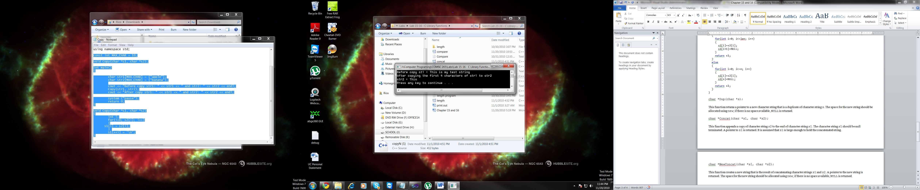 s1[i+1] = NULL;

}

return s1;

}

else

{

for(i=0; i<=n; i++)

{

s1[i] = s2[i];

s1[n] = NULL;

}

return s1;

}

}

**char *Dup(char *s);** *This function returns a pointer to a new character string that is a duplicate of character string s. The space for the new string should be allocated using new; if there is no space available, NULL is returned.*

int main()

{

char* str = {"Test String"};

cout << "str = " << str << endl

<< "and the duplicate str = " << dup(str) << endl;

system("pause");

}

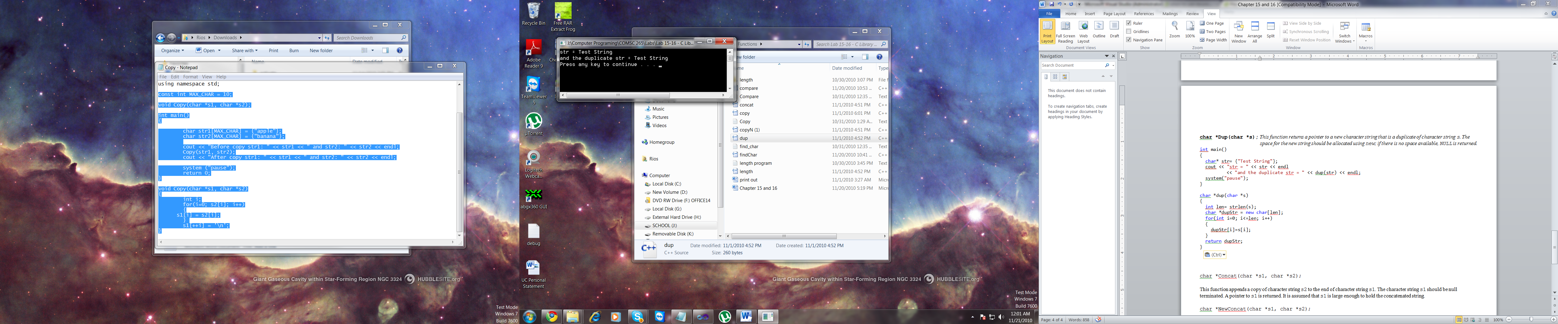

char *dup(char *s)

{

int i, len = strlen(s);

char *dupStr = new char[len];

for(i=0; i<=len; i++)

{

dupStr[i] = s[i];

}

return dupStr;

}

**char *Concat(char *s1, char *s2);** *This function appends a copy of character string s2 to the end of character string s1. The character string s1 should be null terminated. A pointer to s1 is returned. It is assumed that s1 is large enough to hold the concatenated string.*

int main()

{

char str1[90]= {"Test"};

char* str2= {"String"};

cout << "Before Concat str1 = " << str1 << " and str2 = " << str2 << endl;

cout << "After concat str1 = " << Concat(str1, str2) << endl;

system("pause");

}

char *Concat(char *s1, char *s2)

{

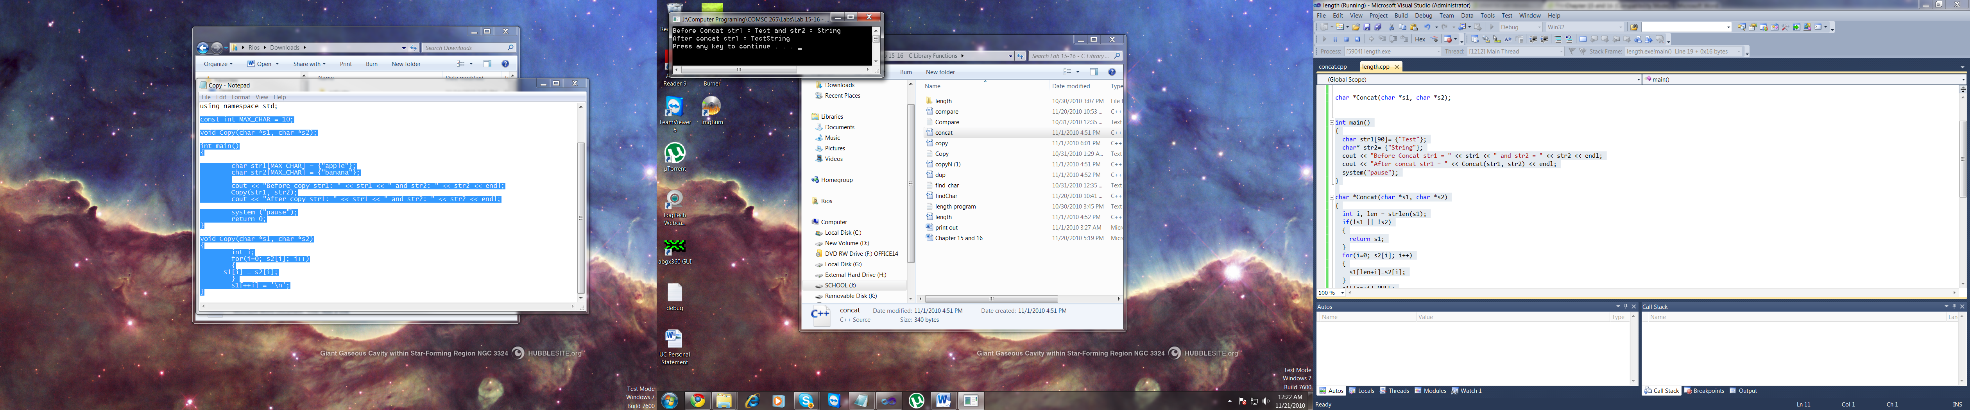 int i, len = strlen(s1);

if(!s1 || !s2)

{

return s1;

}

for(i=0; s2[i]; i++)

{

s1[len+i] = s2[i];

}

s1[len+i] = NULL;

return s1;

}

**char *NewConcat(char *s1, char *s2)**; *This function creates a new string that is the result of concatenating character strings s1 and s2. A pointer to the new string is returned. The space for the new string should be allocated using new; if there is no space available, NULL is returned.*

int main()

{

char str1[90]= {"Test"};

char* str2= {"String"};

cout << "Before Concat str1 = " << str1 << " and str2 = " << str2 << endl;

cout << "After concat the new str3 = " << NewConcat(str1, str2) << endl;

system("pause");

}

char *NewConcat(char *s1, char *s2)

{

int i, j, len1 = strlen(s1), len2 = strlen(s2), len3 = len1+len2;

char *s3 = new char[len3];

if(!s1 || !s2 || sizeof(s3)==0)

{

return NULL;

}

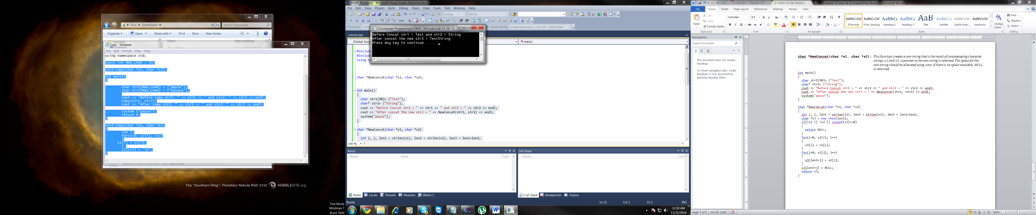 for(i=0; s1[i]; i++)

{

s3[i] = s1[i];

}

for(j=0; s2[j]; j++)

{

s3[len1+j] = s2[j];

}

s3[len1+j] = NULL;

return s3;

}